Sequence Diagrams

COS 420

Team G

Deliverable 3

Miro Link : <https://miro.com/app/board/uXjVNWx-Q5s=/?share_link_id=642075470991>

| **Step #** | **Subject** | **Subject Action** | **Parameters** | **Object Acted Upon** |
| --- | --- | --- | --- | --- |
| 3 | User | clicks | messaging section | Messaging GUI |
| 4 | Messaging GUI | message | userID | Messaging Controller |
| 4.2 | Messaging Controller | sendMessage | userID, message | Messaging Service |
| 4.3 | Messaging Service | send | success | Messaging Controller |
| 4.4 | Messaging Controller | sent | message | Messaging GUI |

UC #4 - Send message

UC #10- Leave Feedback

| **Step #** | **Subject** | **Subject Action** | **Parameters** | **Object Acted Upon** |
| --- | --- | --- | --- | --- |
| 7 | User | selects | feedback | Feedback GUI |
| 7.2 | Feedback GUI | WriteFeedback | feedback, rating | Feedback Controller |
| 7.3 | Feedback Controller | StoreFeedback | feedback,rating | DB Manager |
| 7.3.1 | If storeFeedback successful |  |  |  |
| 7.3.2 | DB Manager | Feedback creation | successful | Feedback Controller |
| 7.2.3 | else |  |  |  |
| 7.2.4 | DB Manager | Feedback creation | unsuccessful | Feedback Controller |
| 7.3 | Feedback Controller | send | feedback status | Feedback GUI |
| 7.4 | Feedback GUI | display | feedback status | User |

UC #13 - Leave tip

| **Step #** | **Subject** | **Subject Action** | **Parameters** | **Object Acted Upon** |
| --- | --- | --- | --- | --- |
| 7 | User | click | submit | Feedback GUI |
| 7.1 | Feedback GUI | finish | feedback | Tip GUI |
| 8 | Tip GUI | display | Tip window | User |
| 9 | User | select | amount | Tip GUI |
| 10 | Tip GUI | display | PayPal window | User |
| 11 | User | fills | credentials | Tip GUI |
| 11.1 | Tip GUI | sendTip | Amount, driverID, cardInfo | Tip Controller |
| 11.2 | Tip Controller | storeTip | Amount, driverID, cardInfo | DB Manager |
| 11.3 | DB Manager | confirm | information | Tip Controller |
| 11.4 | Tip Controller | confirm | information | Tip GUI |
| 11.5 | Tip GUI | close | window | User |

# David Neufeld (1)

| **Name:** | Send Ride Request |
| --- | --- |
| **ID:** | 15 |
| **Description**: | As a passenger, I want to send ride requests to drivers with open seats |
| **Success Postcondition**: | The Driver requested by the user receives a notification for a request. The user receives confirmation that a request has been sent. |

| **STEPS**:  1. Select a driver from a list of available (suitable) drivers  2. System presents a summary of the selected driver.  3. User clicks send carpool request option.  4.System sends a carpool request and the driver receives a notification. The System presents confirmation that a request was sent to the user |
| --- |

| **Step #** | **Subject** | **Subject Action** | **Parameters** | **Object Acted Upon** |
| --- | --- | --- | --- | --- |
| 3 | User | Sends Carpool Request | Driver User Page, time, location | GUI |
| 4.1 | GUI | Send Carpool Request | PID, PID of Driver, time, location | Server |
| 4.2 | Server | Send Driver Notification | Request ID | Notification Service |
| 4.3 | Server | Send confirmation that request was sent | None | GUI |
| 4.4 | GUI | Display Confirmation | Confirmation | User |

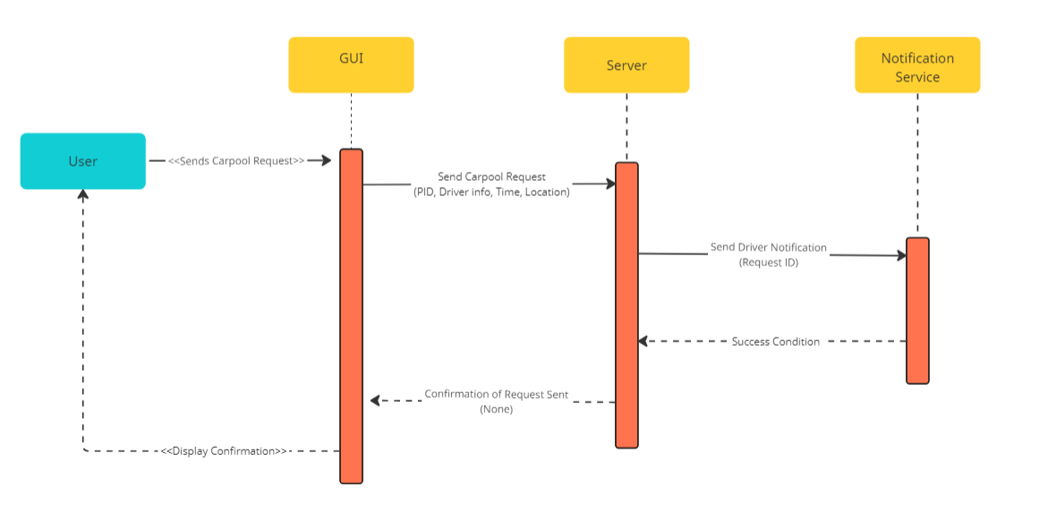

# David Neufeld (2)

| **Name:** | View Past Rides |
| --- | --- |
| **ID:** | 20 |
| **Description**: | The system shall provide users with a list of previous carpool request and provide information about |
| **Success Postcondition**: | The User is presented with a list of rides that has been arranged, with relevant information. |
| **Precondition:** | The user is on the homepage. |

| **STEPS**:  1. User selects ride log option.  2. System presents a list of items, each a summary of past rides, Including time, ride type (to or from campus), and contact information of carpool partner (Name and phone number). |
| --- |

| **Step #** | **Subject** | **Subject Action** | **Parameters** | **Object Acted Upon** |
| --- | --- | --- | --- | --- |
| 1 | User | Select Ride Log | None | GUI |
| 2.1 | GUI | Get past rides involving user | User PID | Database Manager |
| 2.2 | GUI | Displays List | List of rides | User |

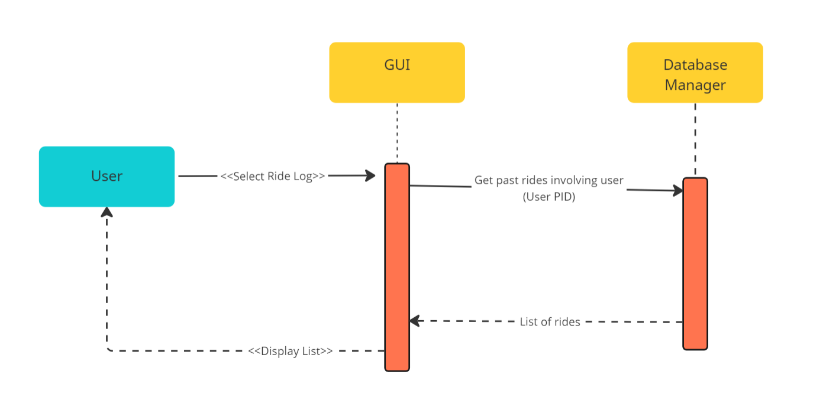

| **Name/Title:** | Accept Request |
| --- | --- |
| **ID:** | 7 |
| **Description**: | A driver receives ride requests from potential passengers who match their schedule. The system allows the driver to view these requests and accept them, subsequently updating the available seats and notifying the requesting passenger. |
| **Success Postcondition**: | The ride request is accepted and recorded in the system. The number of available seats for the driver's carpool listing is updated. The passenger receives a notification that their request has been accepted. |
| **Precondition** | The driver must have an active carpool listing available for passengers to send requests to |

| **STEPS**:  3. Driver navigates to the "Ride Requests" section.  4. System displays a list of ride requests matched to the driver's schedule, with details like passenger name, preferred pickup point, and schedule.  5. Driver selects a specific ride request to view details.  6. System provides a detailed view of the selected ride request, including any notes or messages from the requesting passenger, with the option to accept the request.  7. Driver clicks the "Accept" button for the chosen request.  8. System processes the acceptance, updates the available seats count, and sends a notification to the requesting passenger about the ride request's acceptance. |
| --- |

| **Step #** | **Subject** | **Subject Action** | **Parameters** | **Object Acted Upon** |
| --- | --- | --- | --- | --- |
| 3 | User | Selects “Ride Requests | None | GUI |
| 4 | GUI | Display ride requests | Ride Requests | User |
| 5 | User | Selects a ride request | None | GUI |
| 6 | GUI | Display ride details | Ride Details | User |

| **Step #** | **Subject** | **Subject Action** | **Parameters** | **Object Acted Upon** |
| --- | --- | --- | --- | --- |
| 7 | User | Accepts Request | None | GUI |
| 8 | GUI | Accept Request | Request ID | Server |
| 8.1 | Server | Update Driver Availability | PID | DB Manager |
| 8.2 | Server | Notify Rider | Request ID | Notif. Manager |
| 8.3 | Server | Send Confirmation | None | GUI |
| 8.4 | GUI | Display Confirmation | None | User |

